Flagship Carpets FE118-58A Dot Spots Seating Rug, Everyone Has a Spot on This Colorful Design, 10'9" x 13'2" Seats 36, 129" Length, 158" Width, Multi-Color
by Flagship Carpets
4.5 out of 5 stars 13 customer reviews

| 9 answered questions

Price: | $486.99 FREE Scheduled Delivery
Only 4 left in stock (more on the way).
Ships from and sold by Amazon.com.
Eligible for donation.

Size: 10'9" x 13'2"

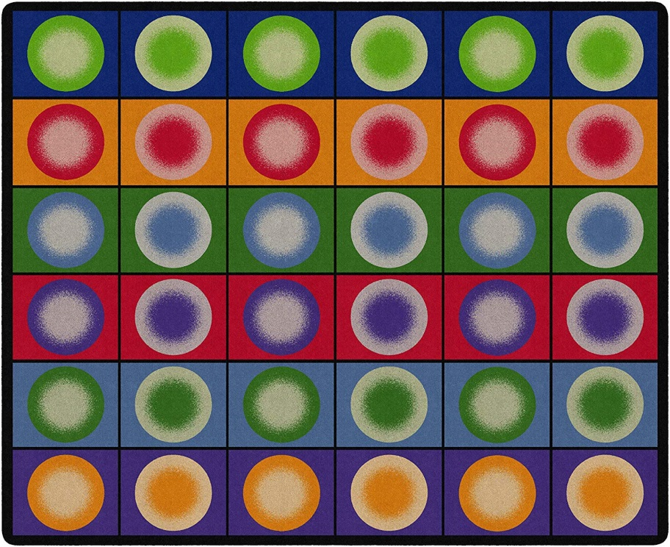

https://smile.amazon.com/gp/product/B008KUIRFW/ref=ox_sc_act_title_1?smid=ATVPDKIKX0DER&psc=1

